Summary of Cones and Needles

A. Pitch Pine: 3 needles; smallish somewhat rounded cone
B. Shortleaf Pine: 2 needles per bundle; egg shaped cone, usually without prickles
C. Virginia Pine: 2 very short, twisted needles per bundle; small cones with thin, sharp prickles
D. White Pine: 5 soft needles with a silvery line per bundle; long, thin cones
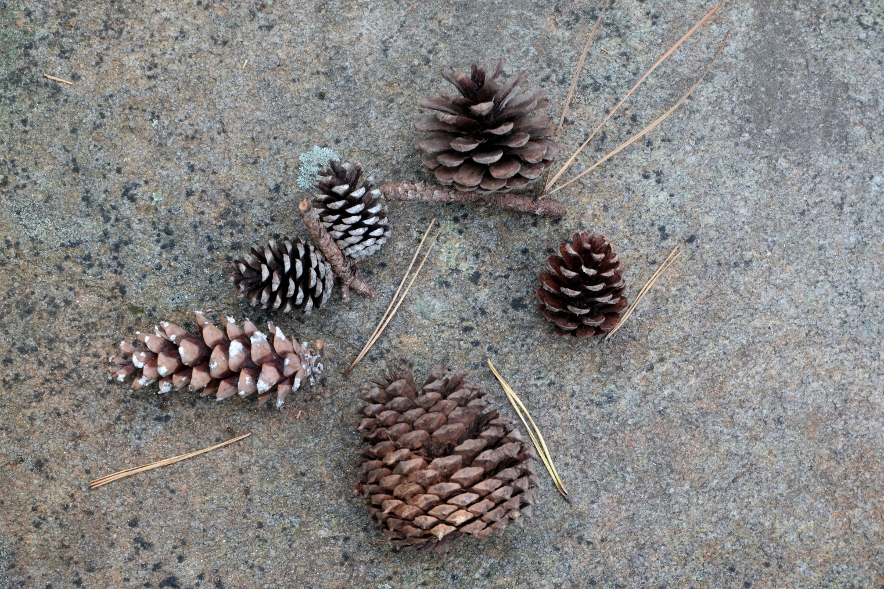E. Table Mountain Pine: 2 stiff, slightly twisted needles per bundle; very distinctive rounded cone with stout, strong “rhinocerous horn” prickles. Some cones open, some cones closed or partly closed.
E. Table Mountain Pine
C. Virginia Pine
A. Pitch Pine
B. Shortleaf Pine
D. White Pine

Photo by Jay Pakchar, taken in Tallulah Gorge on a quartzite rock outcrop

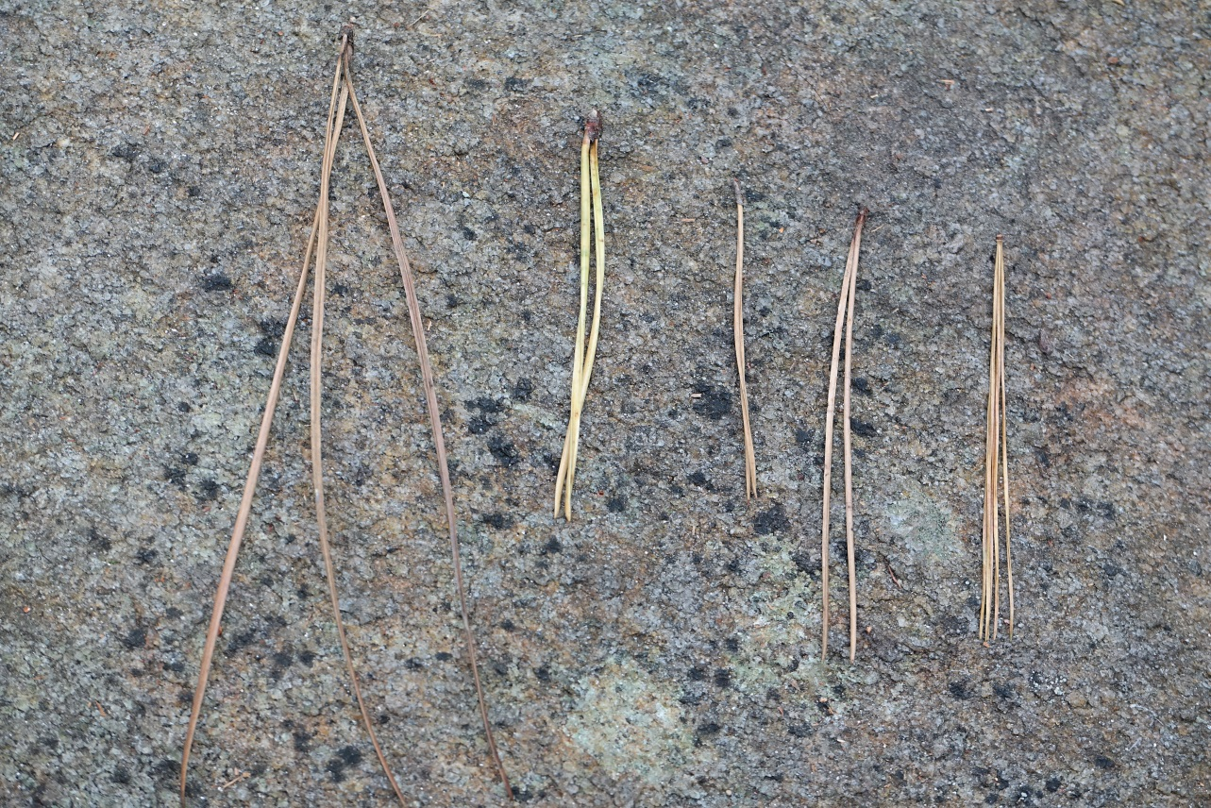
Pitch
Table Mtn
Shortleaf
Virginia
White

